Quality Assurance Director

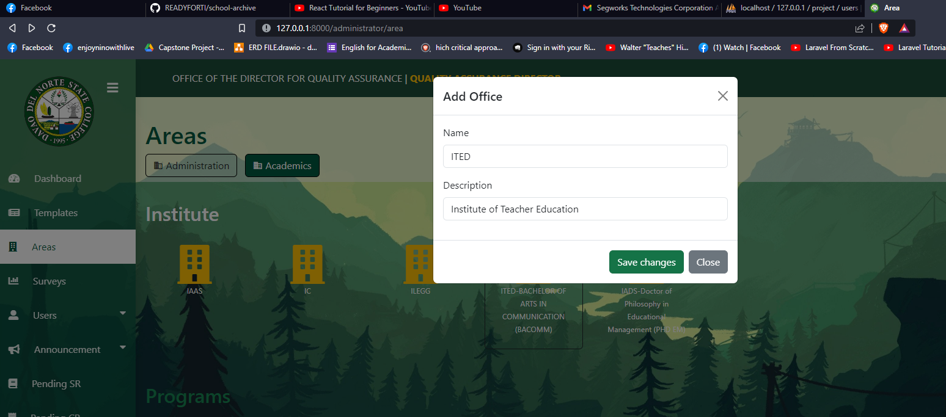



Mag error once mo edit area

Staff

Delete function for users na nag send

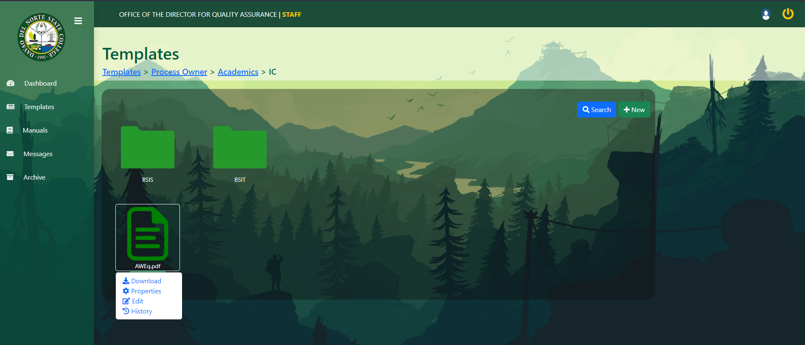

Error templates and manuals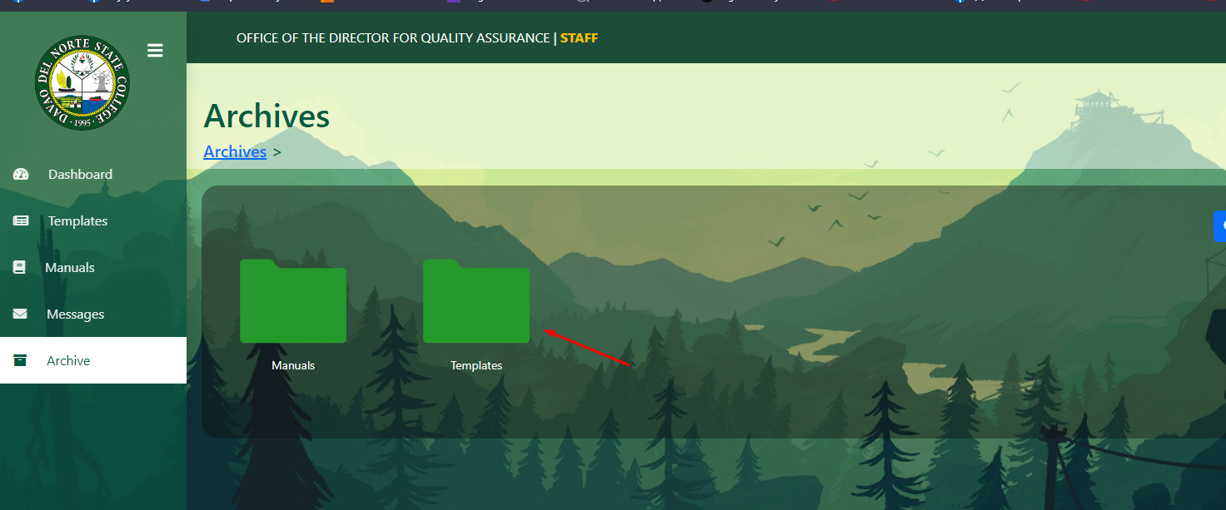

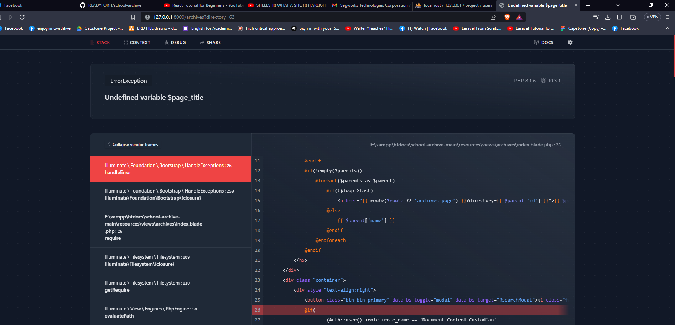

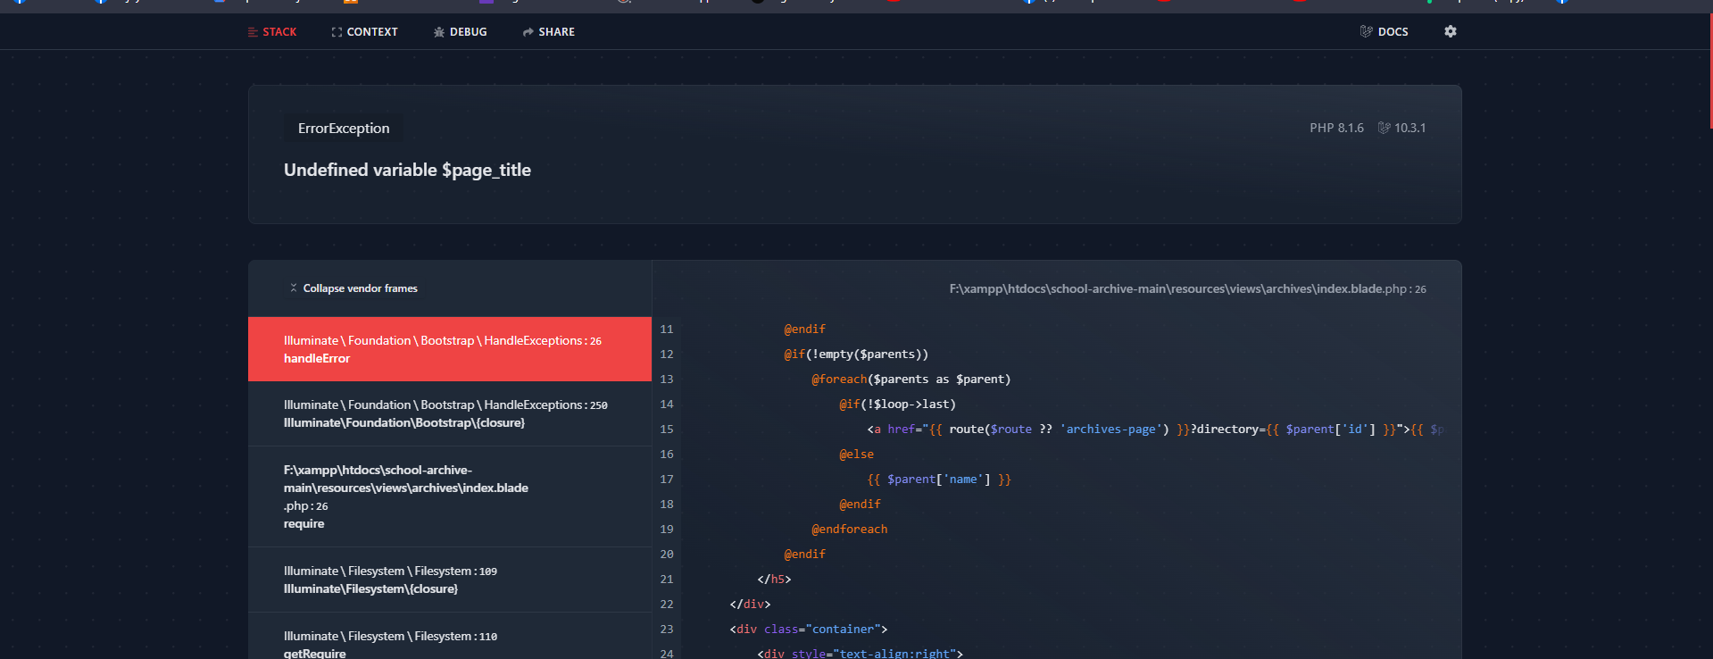

DCC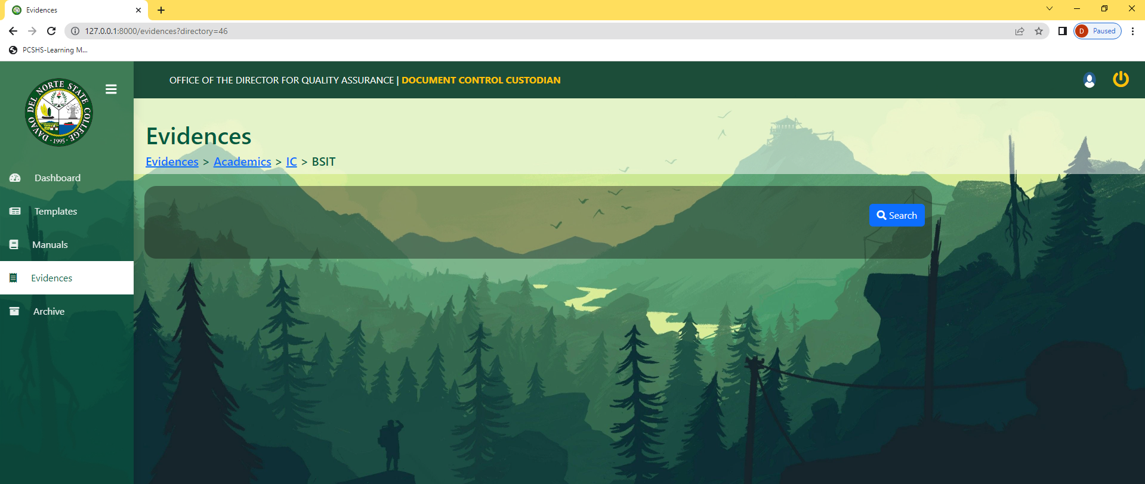

Dleh na maka add ug folder. D ka upload ang Process Owners ani

Mas maau ditso na sa institute/office directory. Para goods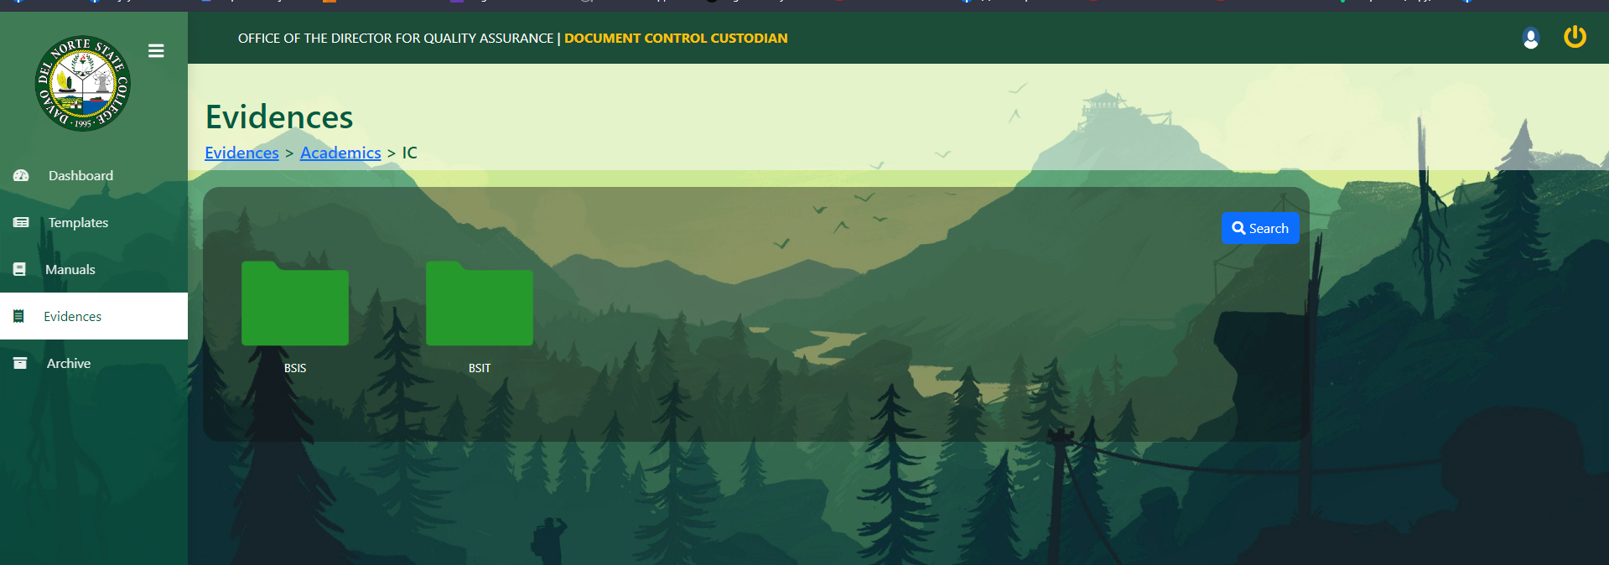

Tanang archive pud kay error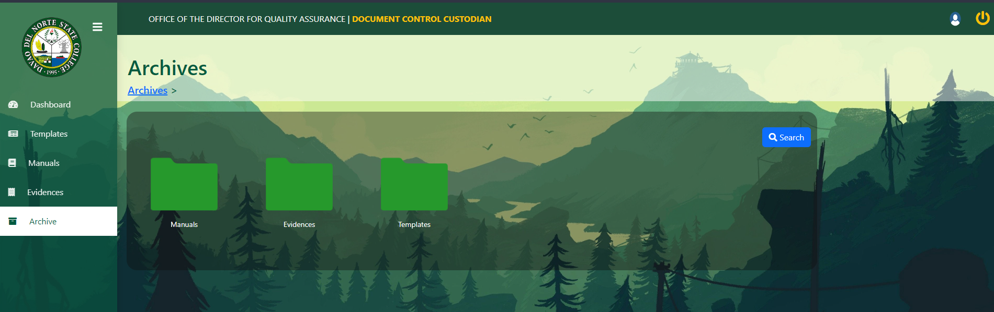

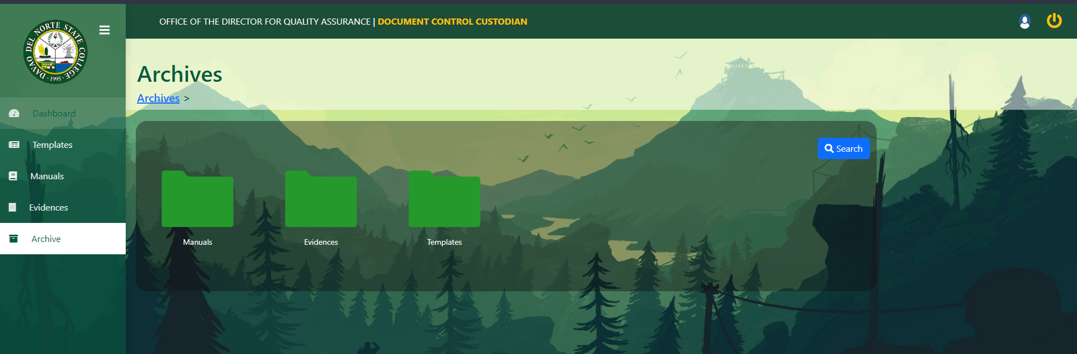

Tanang archive error

Process Owner

Manuals ug Evidence lang I archive. ayaw na apila templates

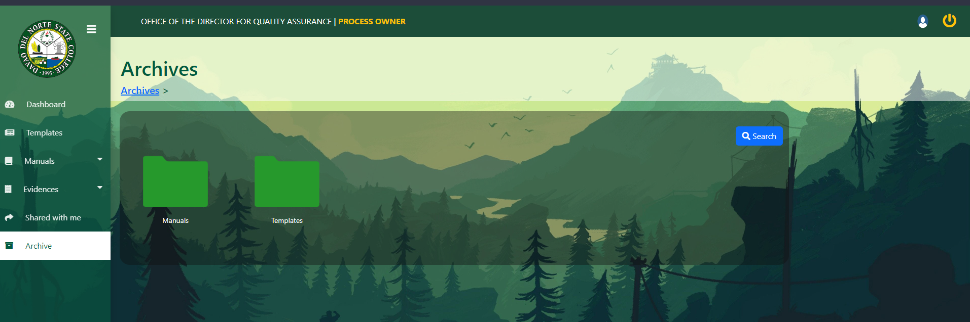

LEAD AUDITOR

Error eaudit report and Consolidated report

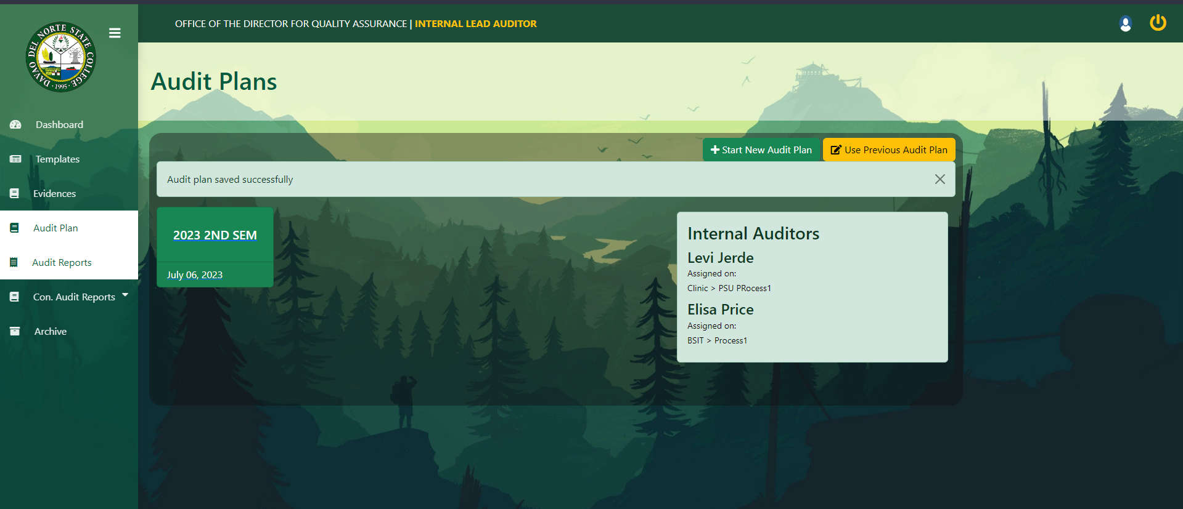

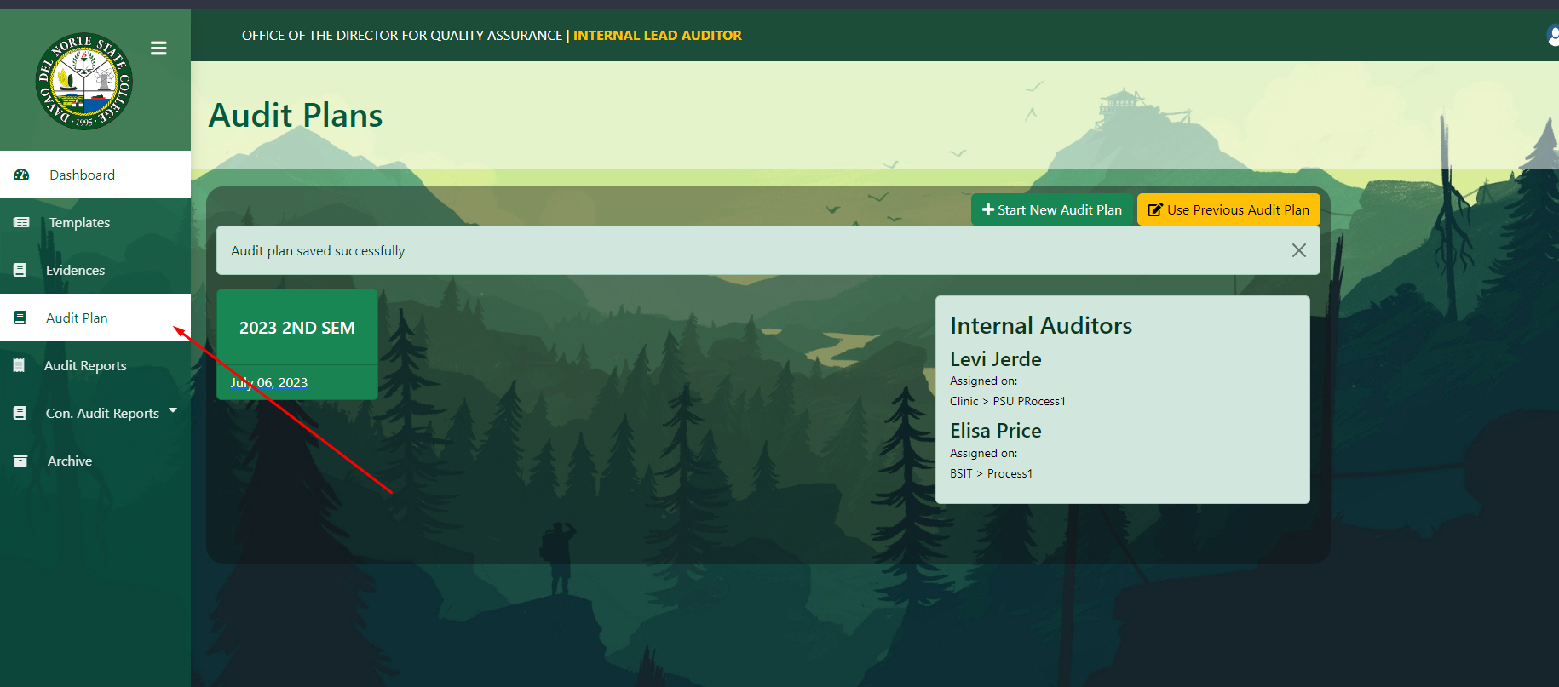

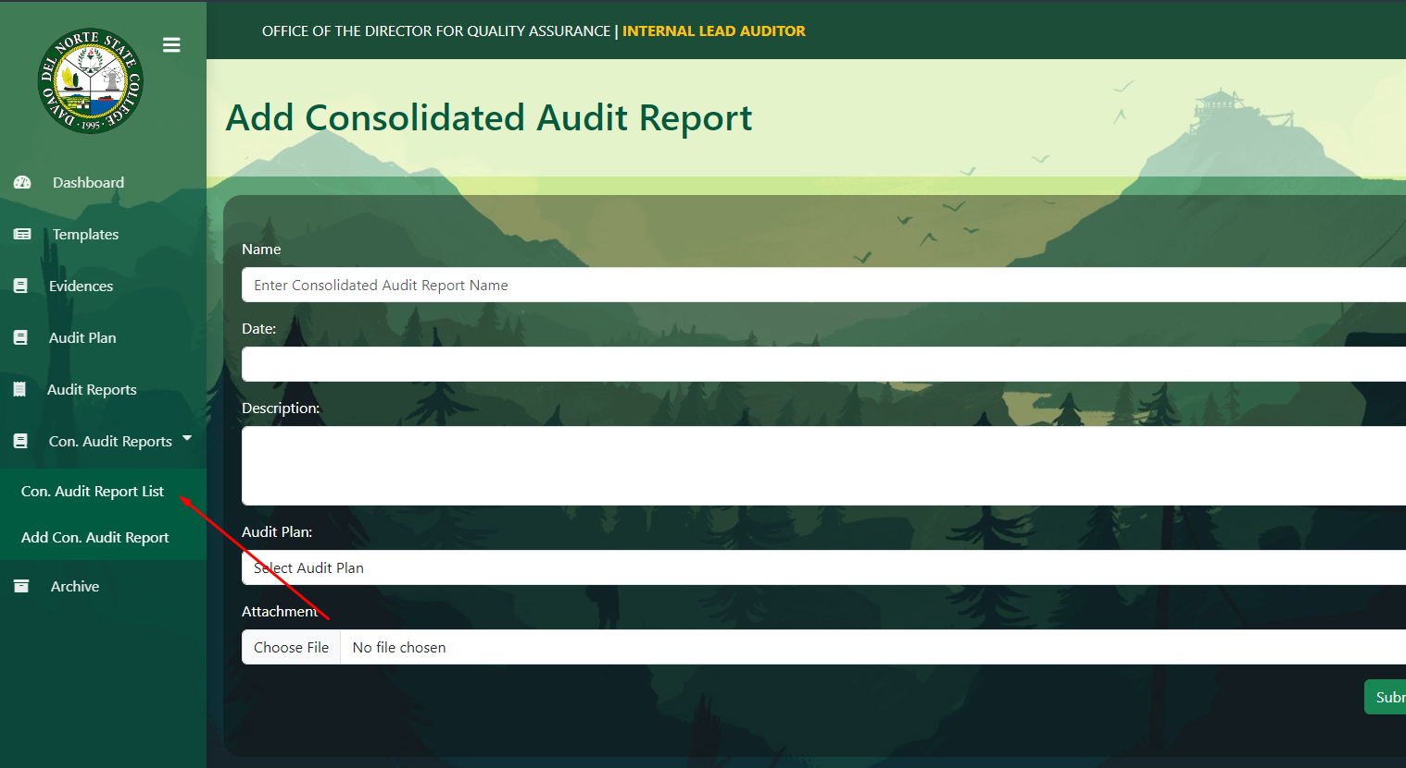

Internal Auditors

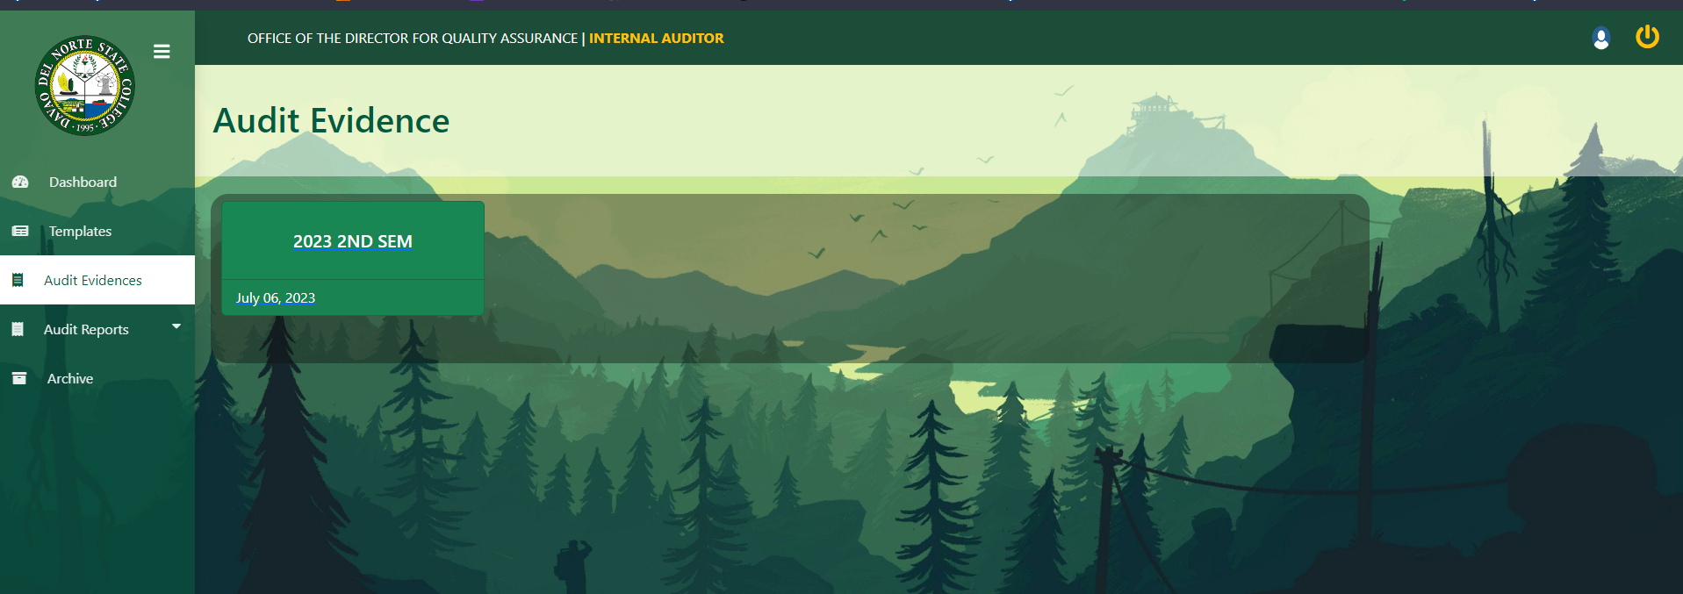

Mag error pag I click

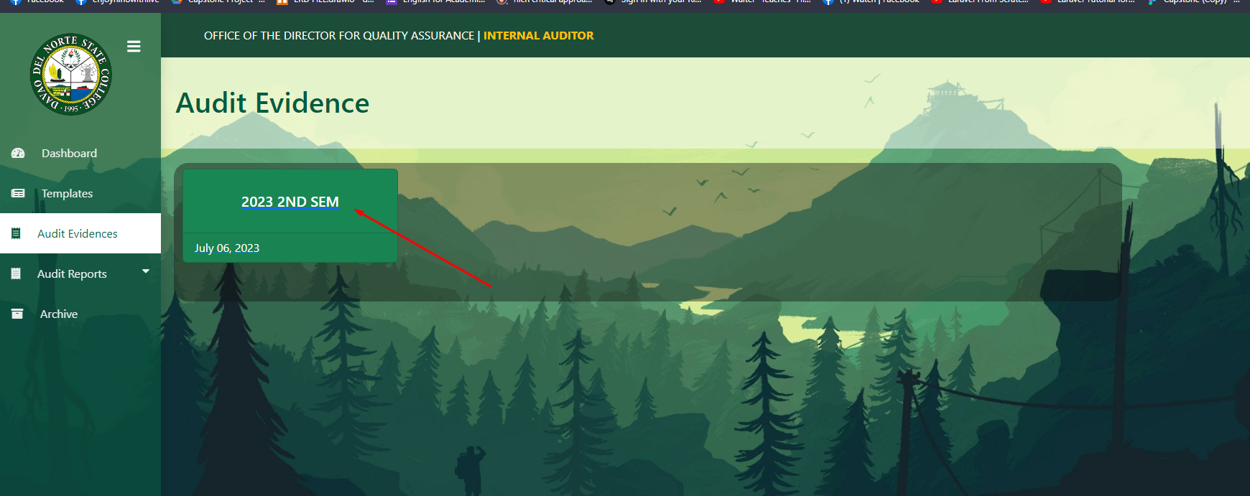

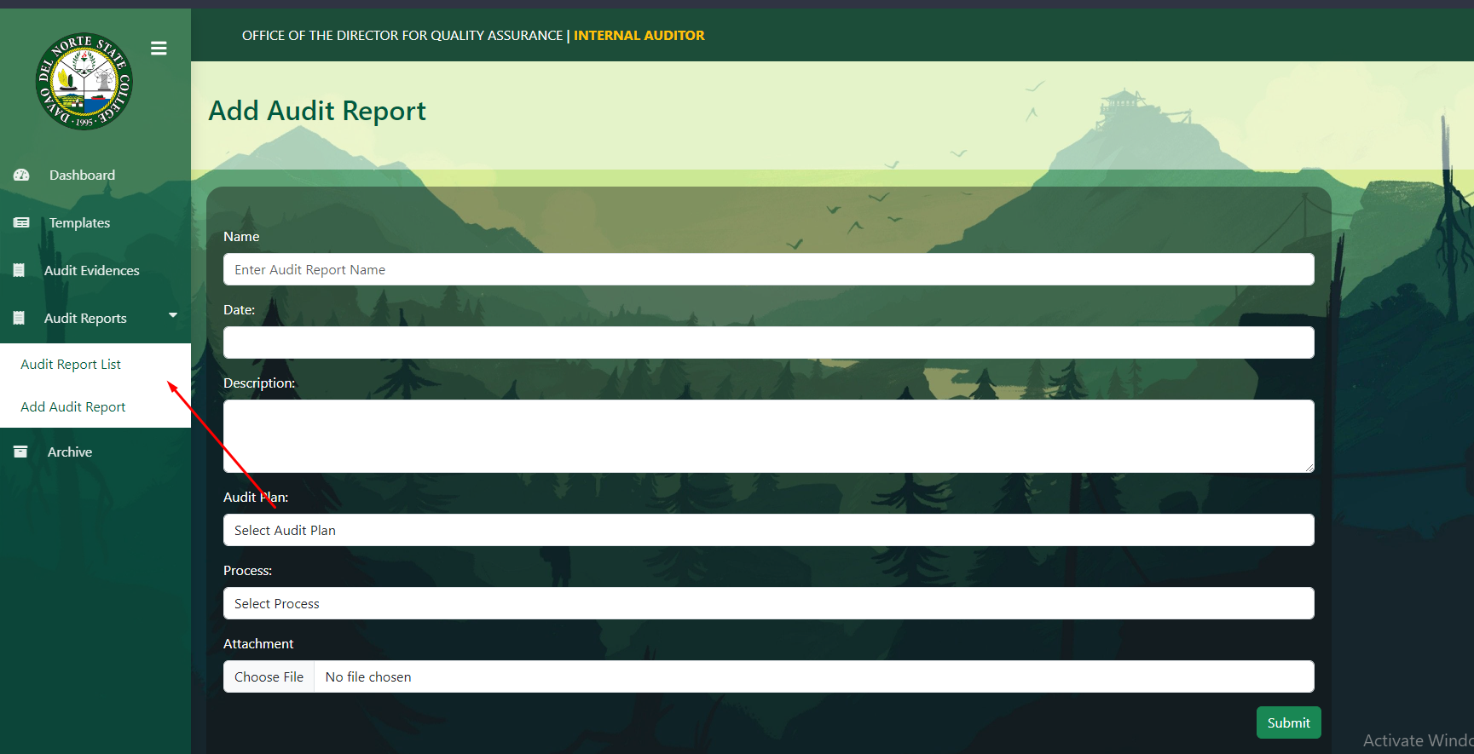

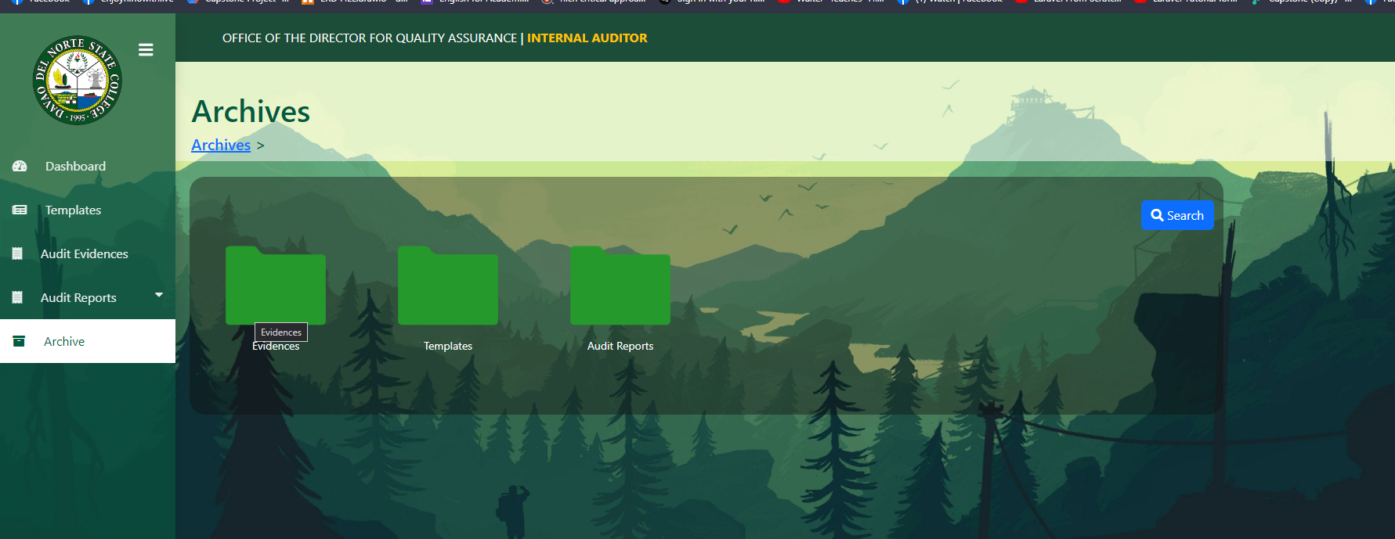

Ug dapat Makita ra niya na evidence kay tanan evidence gi upload or iya lang gi remarkan? Kay Mali ang Makita niya tanang evidence na gi upload sa different process owner

Pwede raman wala na ni dire sa archive tas rather maghimo nalang kag laing directory. Na nakapangalan   
“remarked files” iyang evidence gi remark ma ditso diya

Human Resources.   
  
Error sa Survey reports

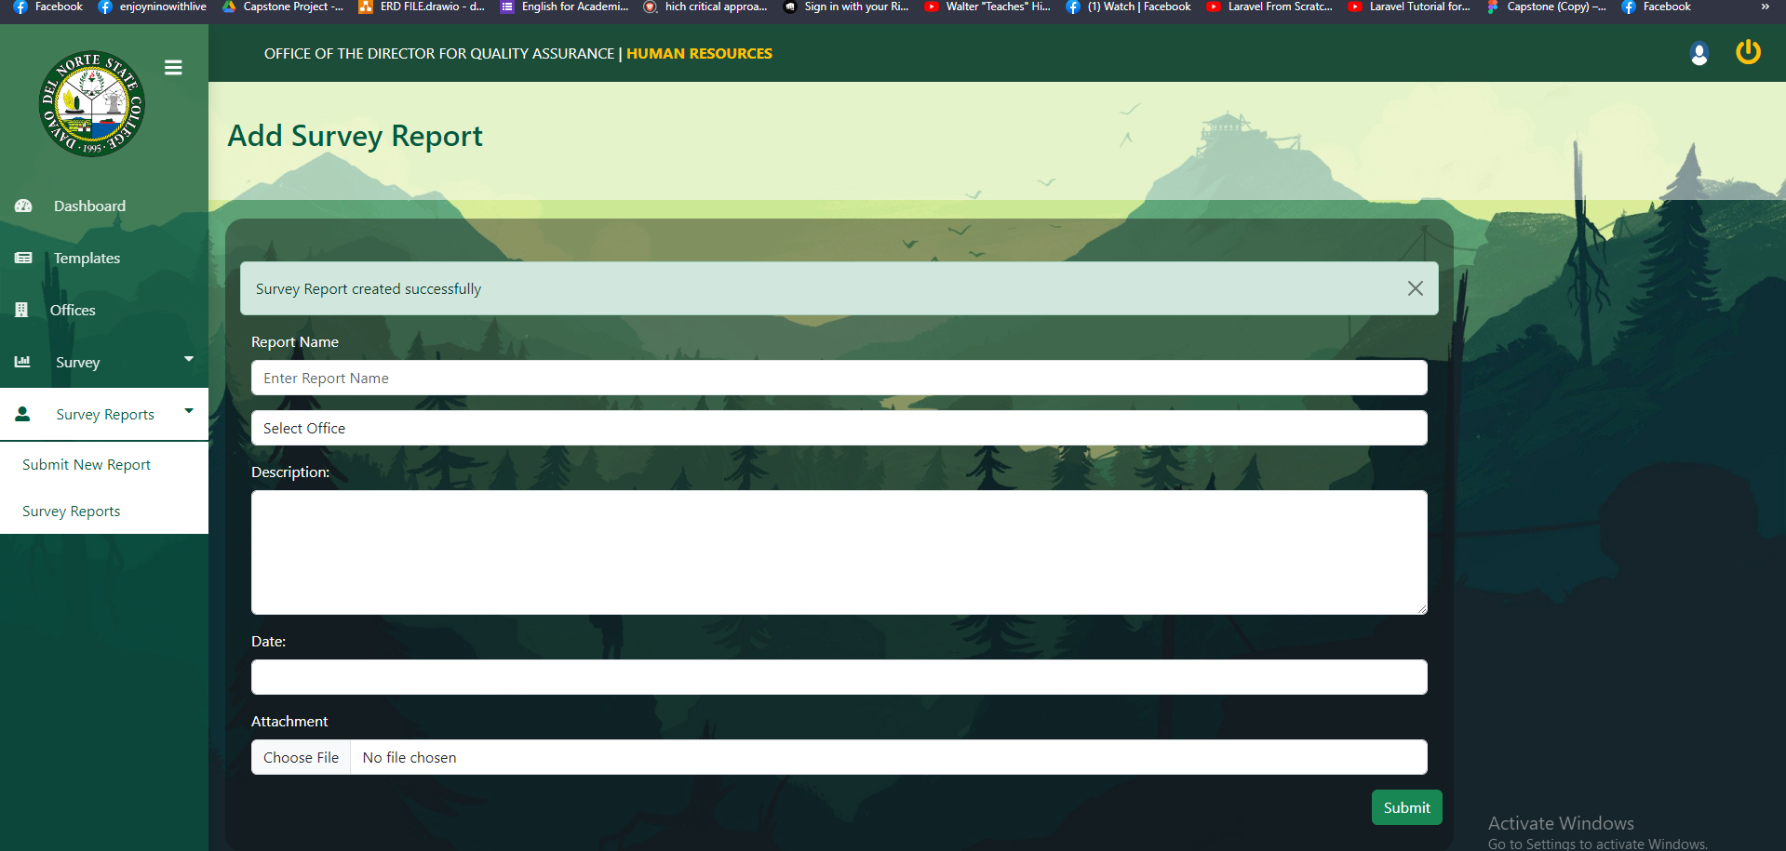

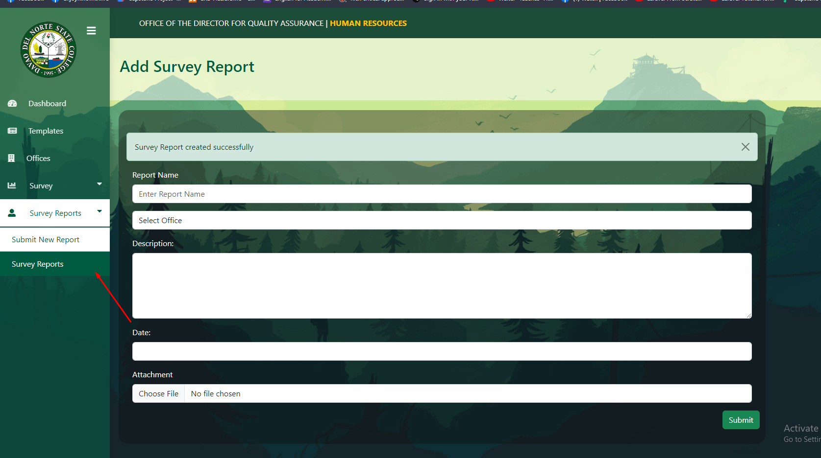

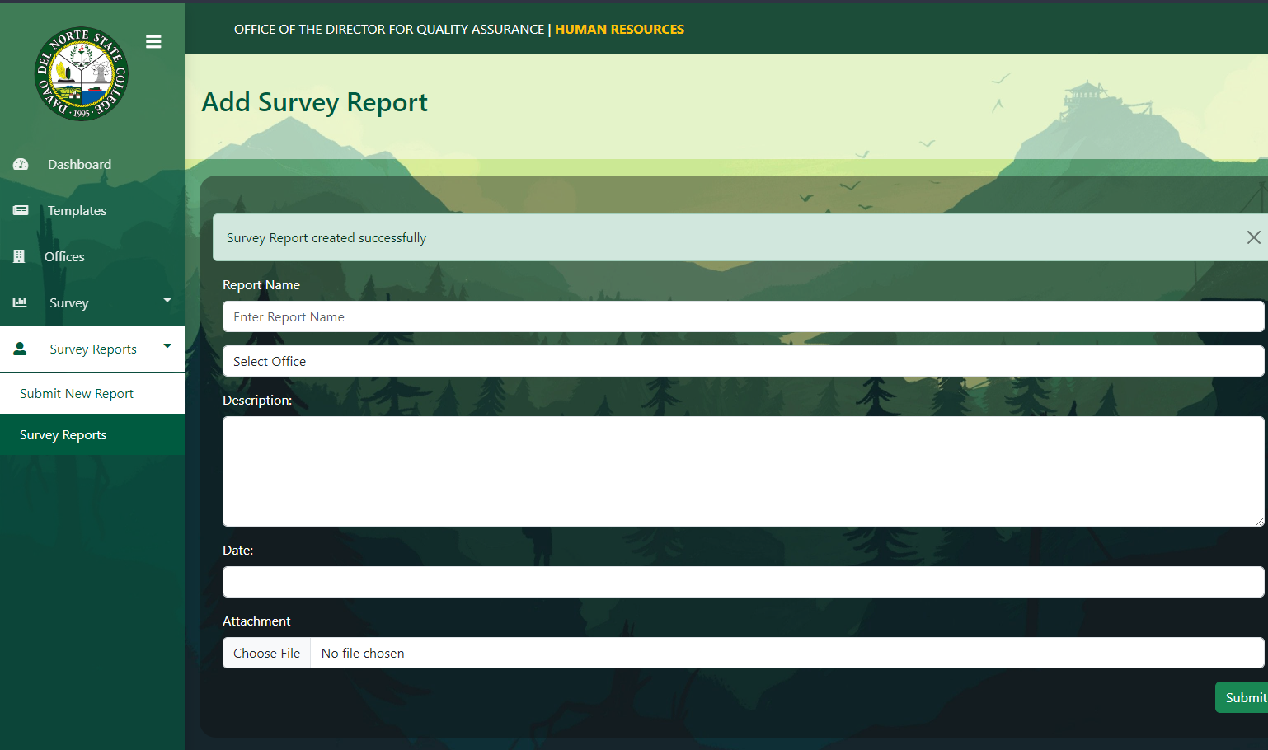missing archive for survey reports

College Management Team

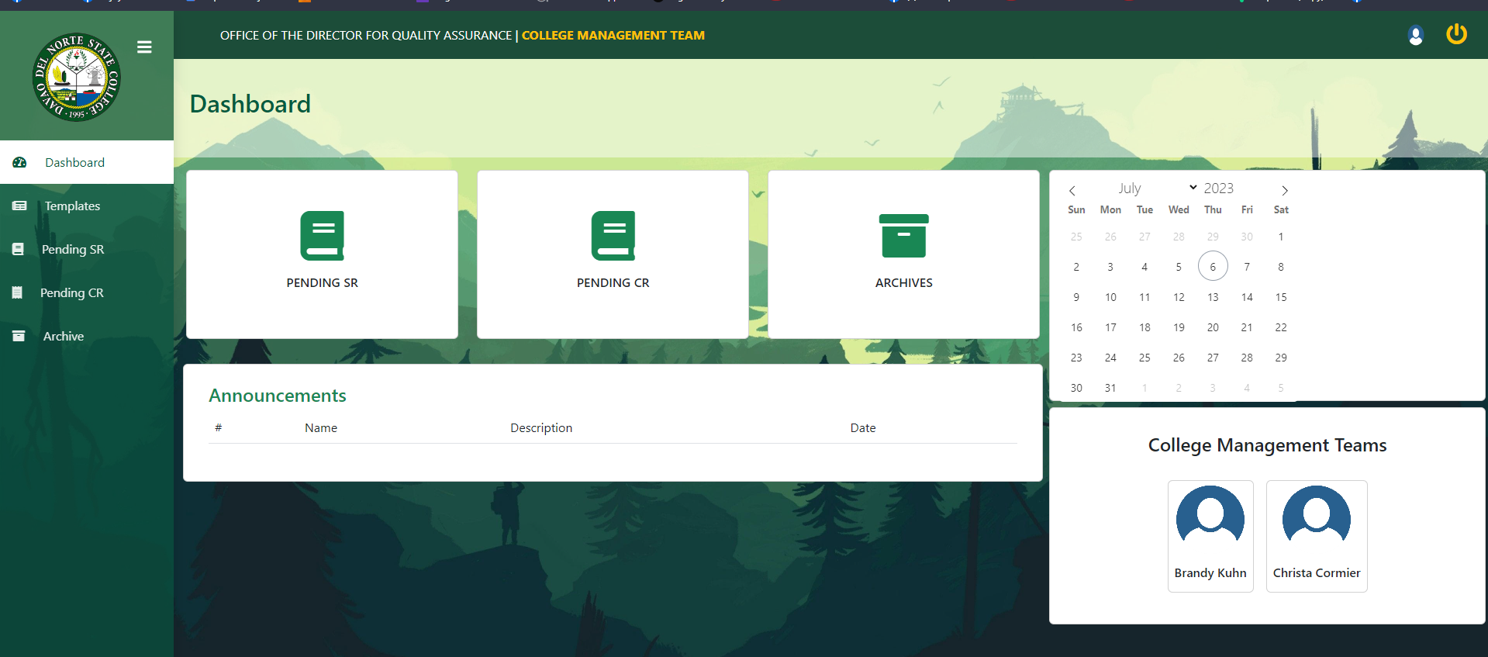

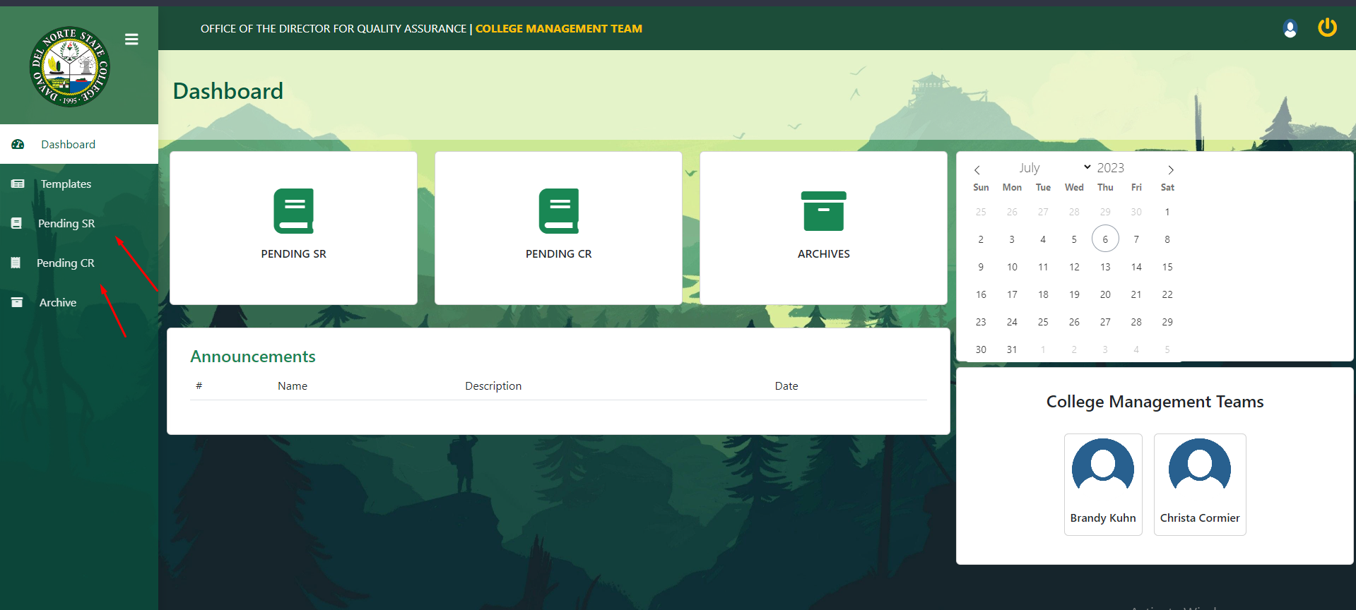

Error ang Pending SurveyR ug Pending CR